USHT-235,6740,11067

UFDF

Table of Contents

U1- Time Benz 2 removed from 2-8 storage 2

U2- Benz 2 2-8 hold time 2

U3- QC sampling 2

U4- Grose weight Benz 2 - POST SAMPLING 2

U5- Tare: 10L for clarified harvest 2

U6- NO DATA FOUND 2

U7- Net weight Benz 2 - POST SAMPLING (A) 2

U8- CHECK 2

U9- Target UFDF Load 2

U10- UFDF Ret PRE SAMPLING 3

U11- UFDF concentration factor 3

U12- Retentate QC Sampling (USHT-261 22) 3

U13- Sampling loss 3

U14- Net weight UFDF Ret - POS SAMPLING (AK) 3

U15- UFDF concentration factor 4

U16- Perm 1 QC Sampling (USHT-261 23) 4

U17- Perm 2 QC Sampling (USHT-261 24) 4

# U1- Time Benz 2 removed from 2-8 storage USHT-235,6740,11067

# U2- Benz 2 2-8 hold time FORMULA

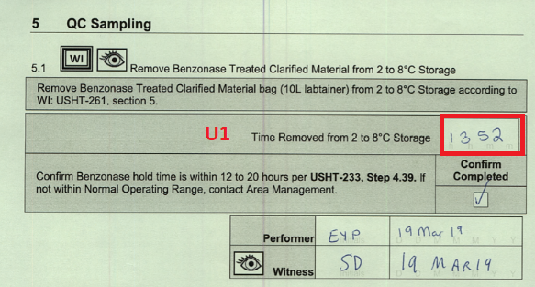

# U3- QC sampling FORMULA

# U4- Grose weight Benz 2 - POST SAMPLING USHT-235,6740,11067

# U5- Tare: 10L for clarified harvest USHT-235,6740,11067

# U6- NO DATA FOUND

# U7- Net weight Benz 2 - POST SAMPLING (A) USHT-235,6740,11067

# U8- CHECK

# U9- Target UFDF Load USHT-235,6740,11067

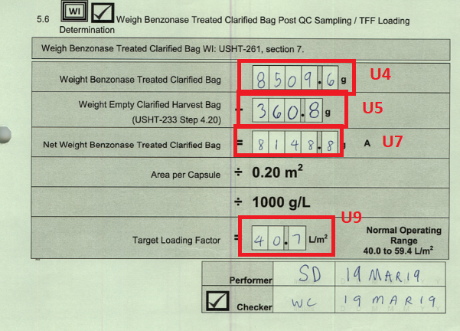

# U10- UFDF Ret PRE SAMPLING FORMULA

# U11- UFDF concentration factor FORMULA

# U12- Retentate QC Sampling (USHT-261 22) -- NO DATA

# U13- Sampling loss FORMULA

# U14- Net weight UFDF Ret - POS SAMPLING (AK) USHT-235,6740,11067

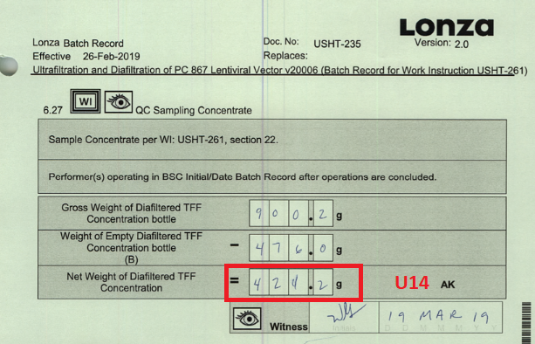

# U15- UFDF concentration factor

# U16- Perm 1 QC Sampling (USHT-261 23)

# U17- Perm 2 QC Sampling (USHT-261 24)